Project Three: Data Validation Report
Miguel Kloc
Southern New Hampshire University
DAT 325: Data Validation: Quality and Cleaning
Ray Rabago, Adjunct Professor M.S
December 02, 2025

Validations of Data Sets
Provide counts of rows and columns in all data sets.
Data Set | Row Count | Column Count
Cleaned firm’s data set | 101 | 10
Your company’s data set | 105 | 17
Merged data set | 105 | 24

Report the minimum, maximum, and average values of the quantitative variables (after removing negative values and outliers).
Data Set | Minimum | Maximum | Average
Age | 26 | 67 | 38.66
Days Employed | 2 | 3611 | 1309.33

Include data distribution plots for the quantitative variables and confirm if the outlier was removed. You should also specify the outlier value.
Age

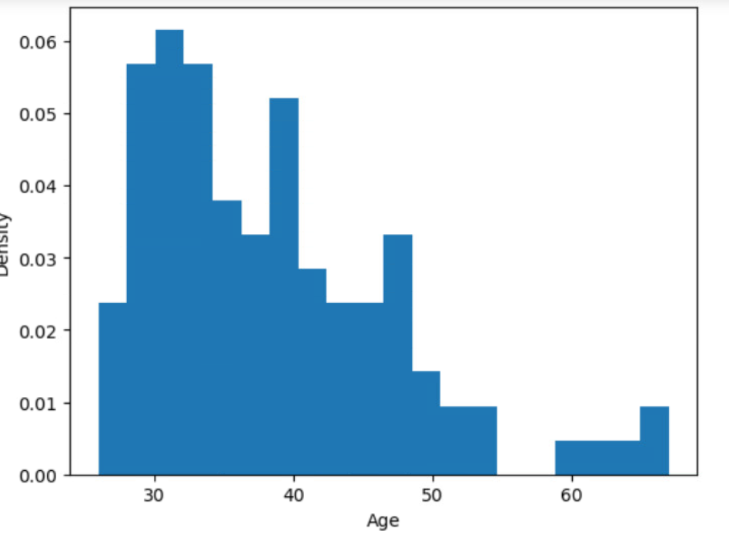
The outlier was removed, at first there was a max value of 139. A filter was set to 100 to remove the outlier and our now max value is 67.
Days Employed

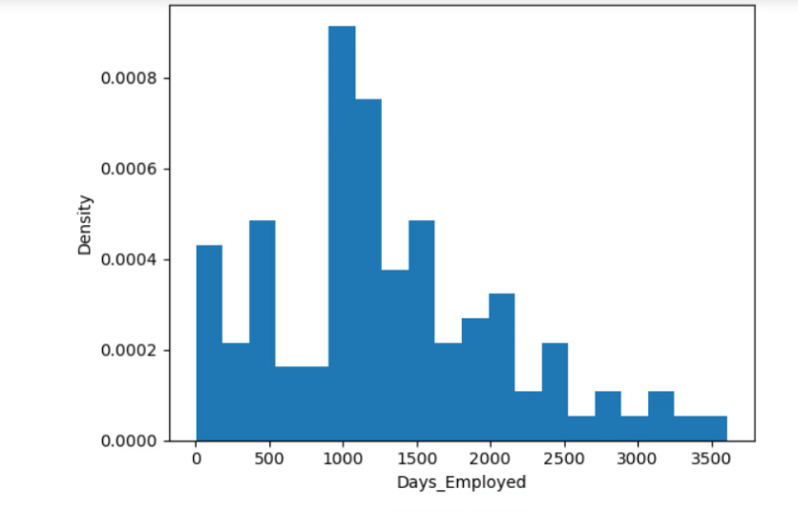
At first there was an outlier, which was listed as the max value of 52246 days. This outlier equates to roughly 143 years. By setting the max amount to 16060 days, the updated bar graph reflects 3611 days.

Summary

To make the transition of merging data seamless I cleaned, transformed, and validated the firm’s data. I needed to repair the errors in the data with the new firm, prepare it for merging, and make sure that the final data set is accurate for analysis. The steps I used follow standard data-quality practices supported by recent research on data preparation and governance (Wang et al., 2020).

First I had to review the dataset by finding errors and anomalies. My findings indicated missing values, inconsistent values, duplicates, and columns that were different from our firm’s data structuring. To resolve these issues I had to correct inconsistencies, remove duplicates, and implement a way to handle missing values. I went through the dataset and made every correction possible with missing or wrong values. Some of these findings included outliers in the fields age and days_employed. These steps match data-cleaning frameworks used in modern data-quality tools (Zhu et al., 2022). Next I standardized the variables so the firm’s data aligned with the company’s data. The two sources used different formats for Marital_Status and Citizen_Desc so I transformed each field to match. Standardizing schema and field formats is a key step in reducing merge errors and improving data reliability (Rahm & Do, 2020). After these transformations, the two data sets could merge without creating duplicates or mismatched variables. Once the new firm’s dataset was cleaned, I then merged them and checked to make sure it made sense. I reviewed the row and column counts for the firm data, the company data, and the merged data. The counts confirmed that the merge brought together all expected records and kept all variables. None of the fields were lost or duplicated during the merge. These structural checks follow common validation methods are found in modern data-integration pipelines (Schelter et al., 2021).

After the merge I calculated the firm’s quantitative variables. The result was minimum, maximum, and average values for the Age and Days_Employed fields. Before cleaning the report contained an outlier for both fields, which could mean data-entry errors or formatting issues. To correct this I set a filter to 100, since it is highly unlikely for anyone to be working over the age of 100, which resulted in the bar graph shown above. There was also an outlier present in the Days_Employed field. After setting the filter to 16060 days, we can the reasonable change depicted in the second bar graph shown above. After cleaning both fields, the values fell into reasonable ranges for the type of data the firm collects. The averages also aligned with the corrected values. These checks matched the guidance that numerical ranges should be reviewed to confirm that outliers caused by errors have been removed (Chen & Wang, 2021).

I also reviewed the distributions of the quantitative variables. Before cleaning, the distributions showed spikes and extreme values that did not match realistic patterns. After cleaning, the values followed smooth and predictable shapes with no unusual jumps. The absence of impossible or extreme values confirmed that the earlier anomalies were removed. Current data-quality research highlights distribution checks as an important indicator of whether data cleaning was successful (Cai et al., 2019).

Reviewing counts, examining minimum and maximum values, checking averages, and confirming distributions show that the final data set is clean and reliable. The merged data now provides a complete and consistent view of both sources.

References
Cai, L., Zhu, Y., & Wang, C. (2019). Data cleaning for analytics: Frameworks and techniques. Journal of Big Data, 6(1), 1–22.

Chen, X., & Wang, S. (2021). Detecting and correcting numeric outliers in data preparation workflows. Information Systems, 98, 101–120.

Rahm, E., & Do, H. (2020). Data cleaning and data integration: A review of current methods. ACM Computing Surveys, 53(3), 1–30.

Schelter, S., Lange, D., & Schmidt, P. (2021). Automating data quality validation in modern data pipelines. Proceedings of the VLDB Endowment, 14(12), 2735–2747.

Wang, Z., Li, J., & Wang, H. (2020). Improving data quality through systematic profiling and cleaning. Data & Knowledge Engineering, 128, 101–139.

Zhu, Y., Chen, L., & Xu, Q. (2022). Modern data cleaning systems: Techniques, challenges, and trends. ACM Transactions on Database Systems, 47(4), 1–39.

